User manual

* 1. Pre-requisite/Terms used.
* Install DBMS PostgreSQL - Download the latest version of PostgreSQL from <https://www.postgresql.org/>
* Register a local server - Under the default server group in PostgreSQL (pgAdmin4 UI), Use localhost as host name and set user password (later used to connect the server)

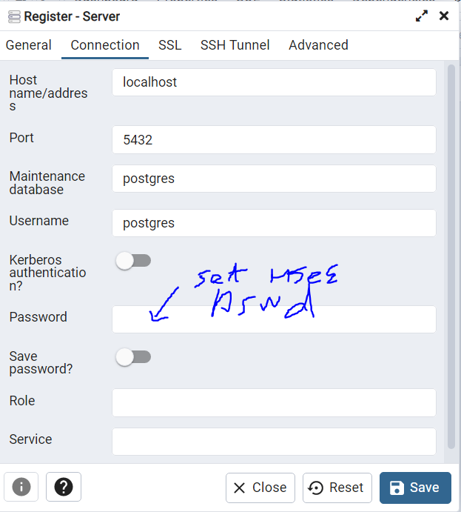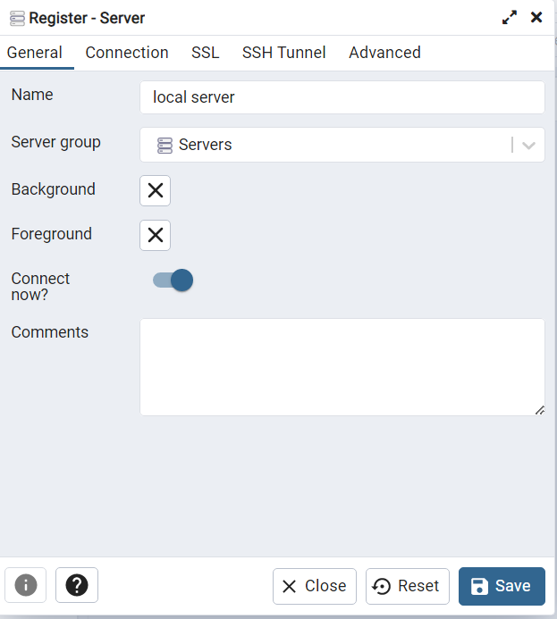

* 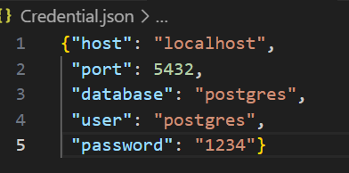Connect to SQL database: In Credential. Json, change t user and password accordingly (the same password used to register the server). By default, postgres is the default username.
* Python interpreter (Python version from 3.6 to 3.10): The psycopg2 library we used only supports Python version from 3.6 to 3.10.
* HTTPS connection: The CA certificate (rootSSL.pem) needs to be manually added to the Trusted Root Certification Authorities.

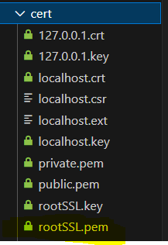 In certificate folder copy the path for rootSSL.pem

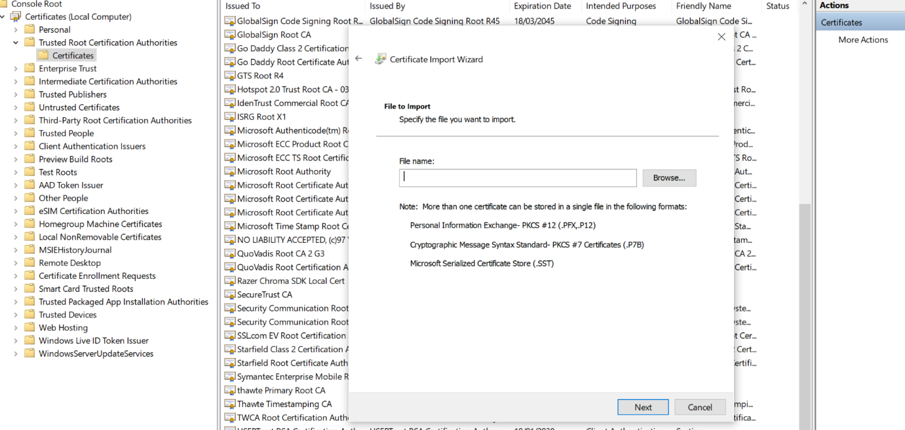 Open MMC Certificates(Local Computer), in More Actions select import and copy the absolute path for rootSSL.pem into the file name. Click next and follow the rest instrunctions.

After finishing the Certificate Import Wizard the CA (wwh) will be found in the Trusted Root Certification Authorities.



* 1. Run the Local Shop server – open controller.py and press run button and go to https://localshop.com:8081

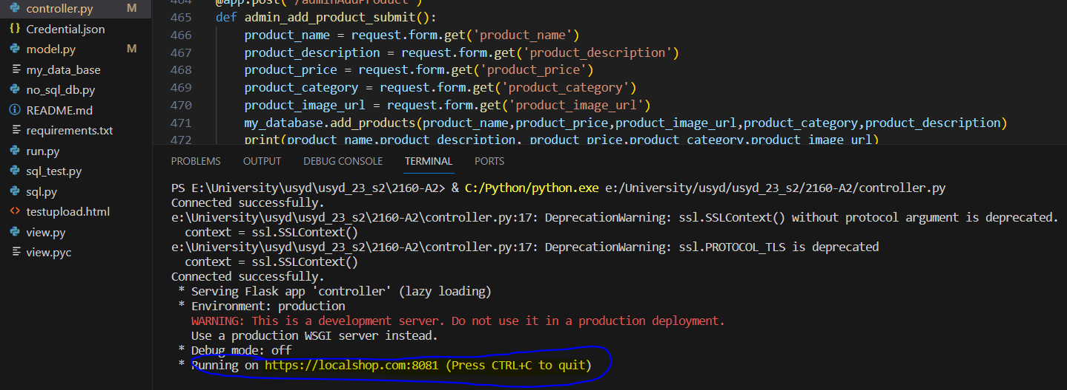

* 1. Register User Account – Double click the register button to register a user account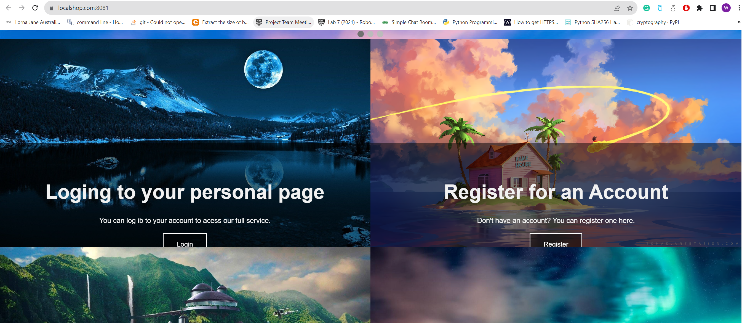

Type username and password to register a user account. If the username has already been taken the registration will fail.

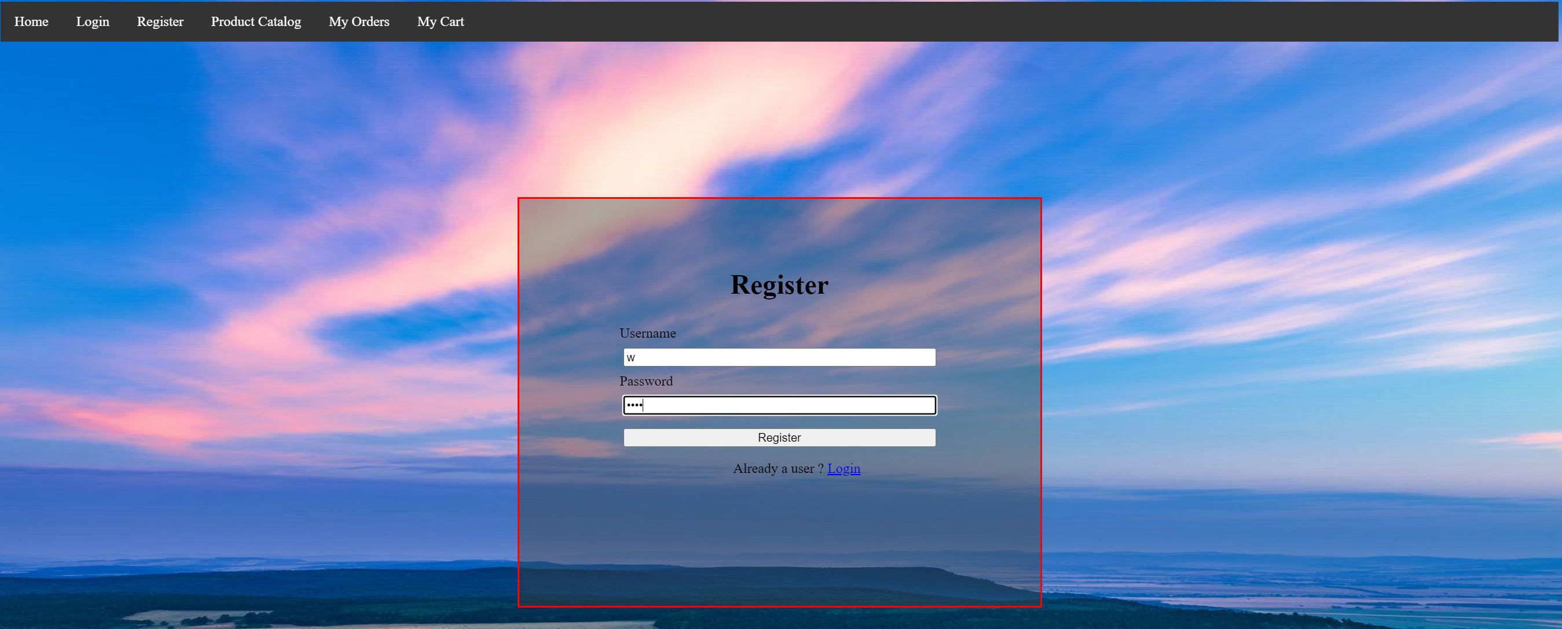

* 1. Log in User Account – After finishing registration, the website will redirect users to a log in page. Users can log in their account using the username and password they created in the register page.

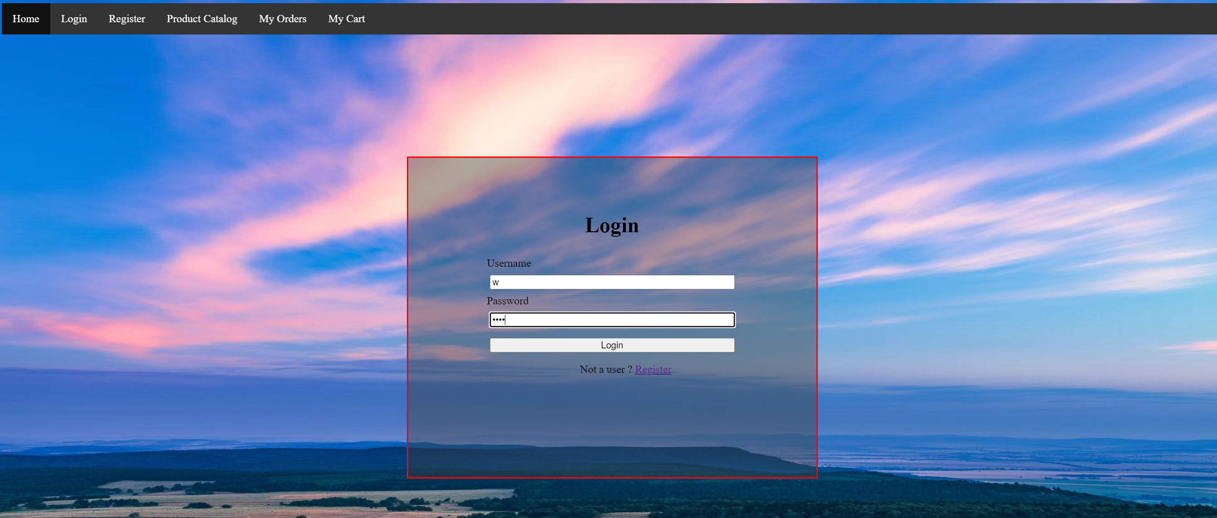

* 1. View product – Users can view product on the product page, Product page can be accessed either though the home page or log in a user account.

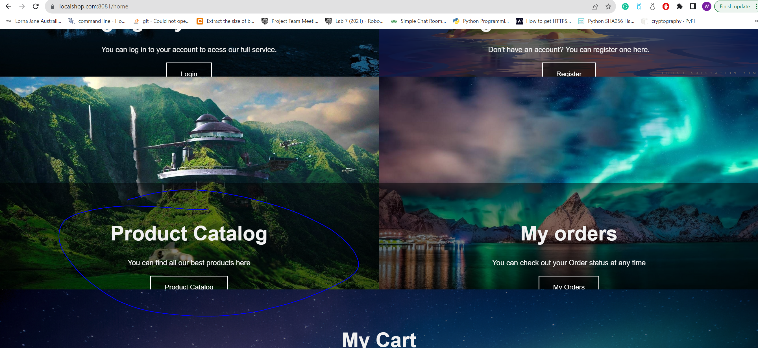

The product page shows all products in the shop , user can filter products by category to view products under a specific category.

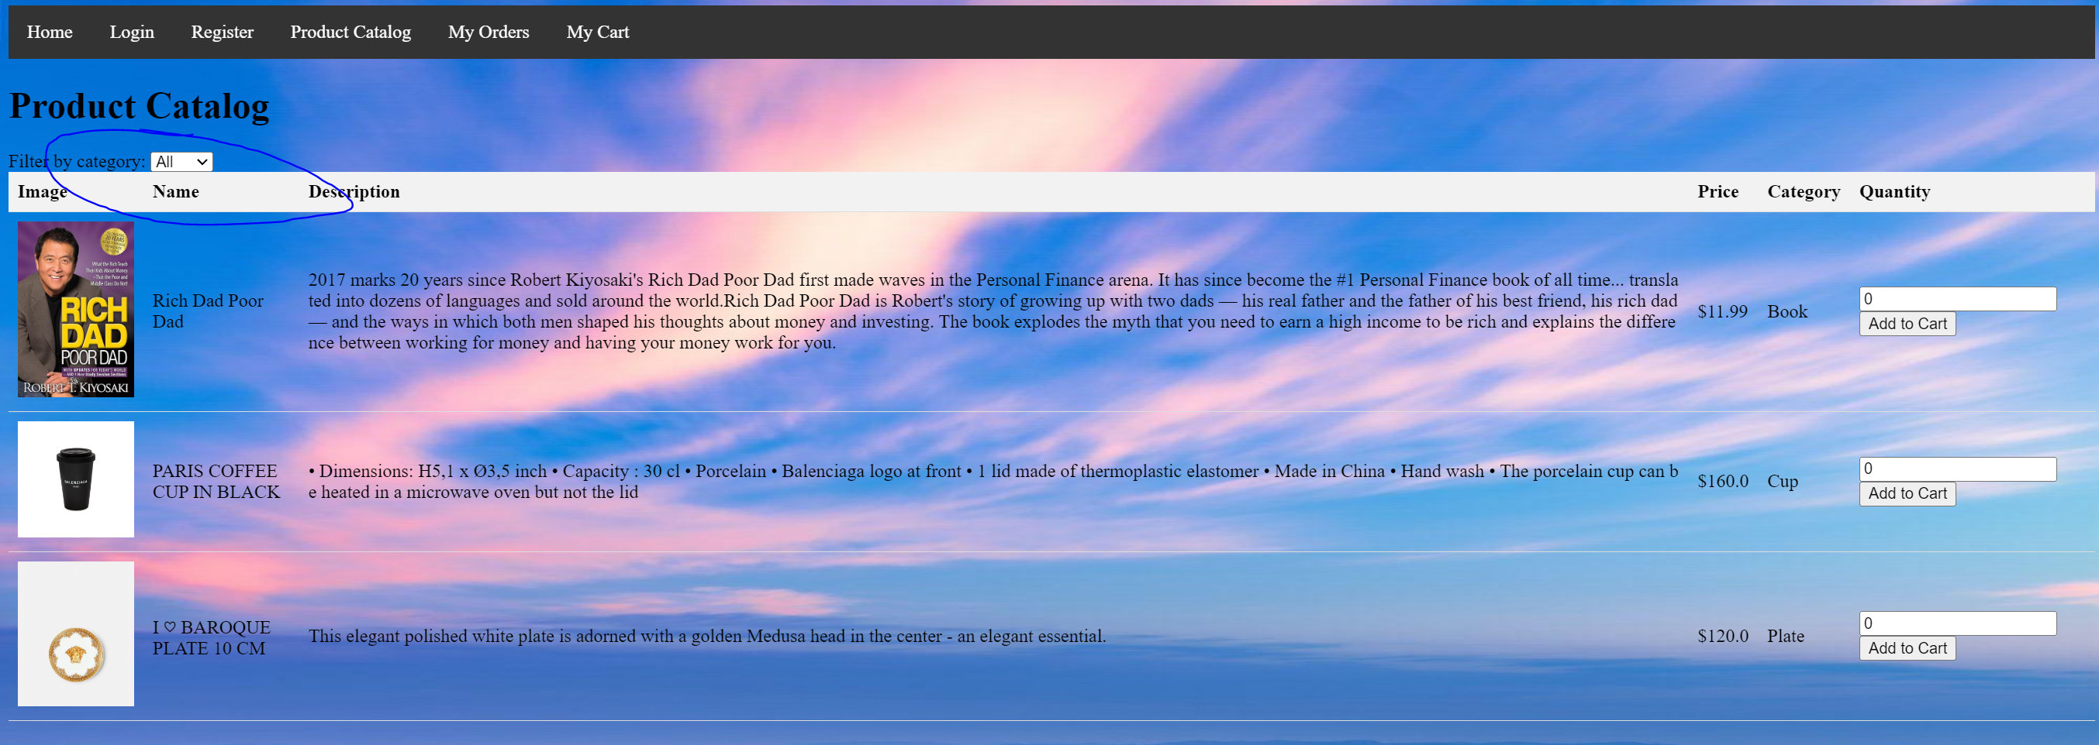

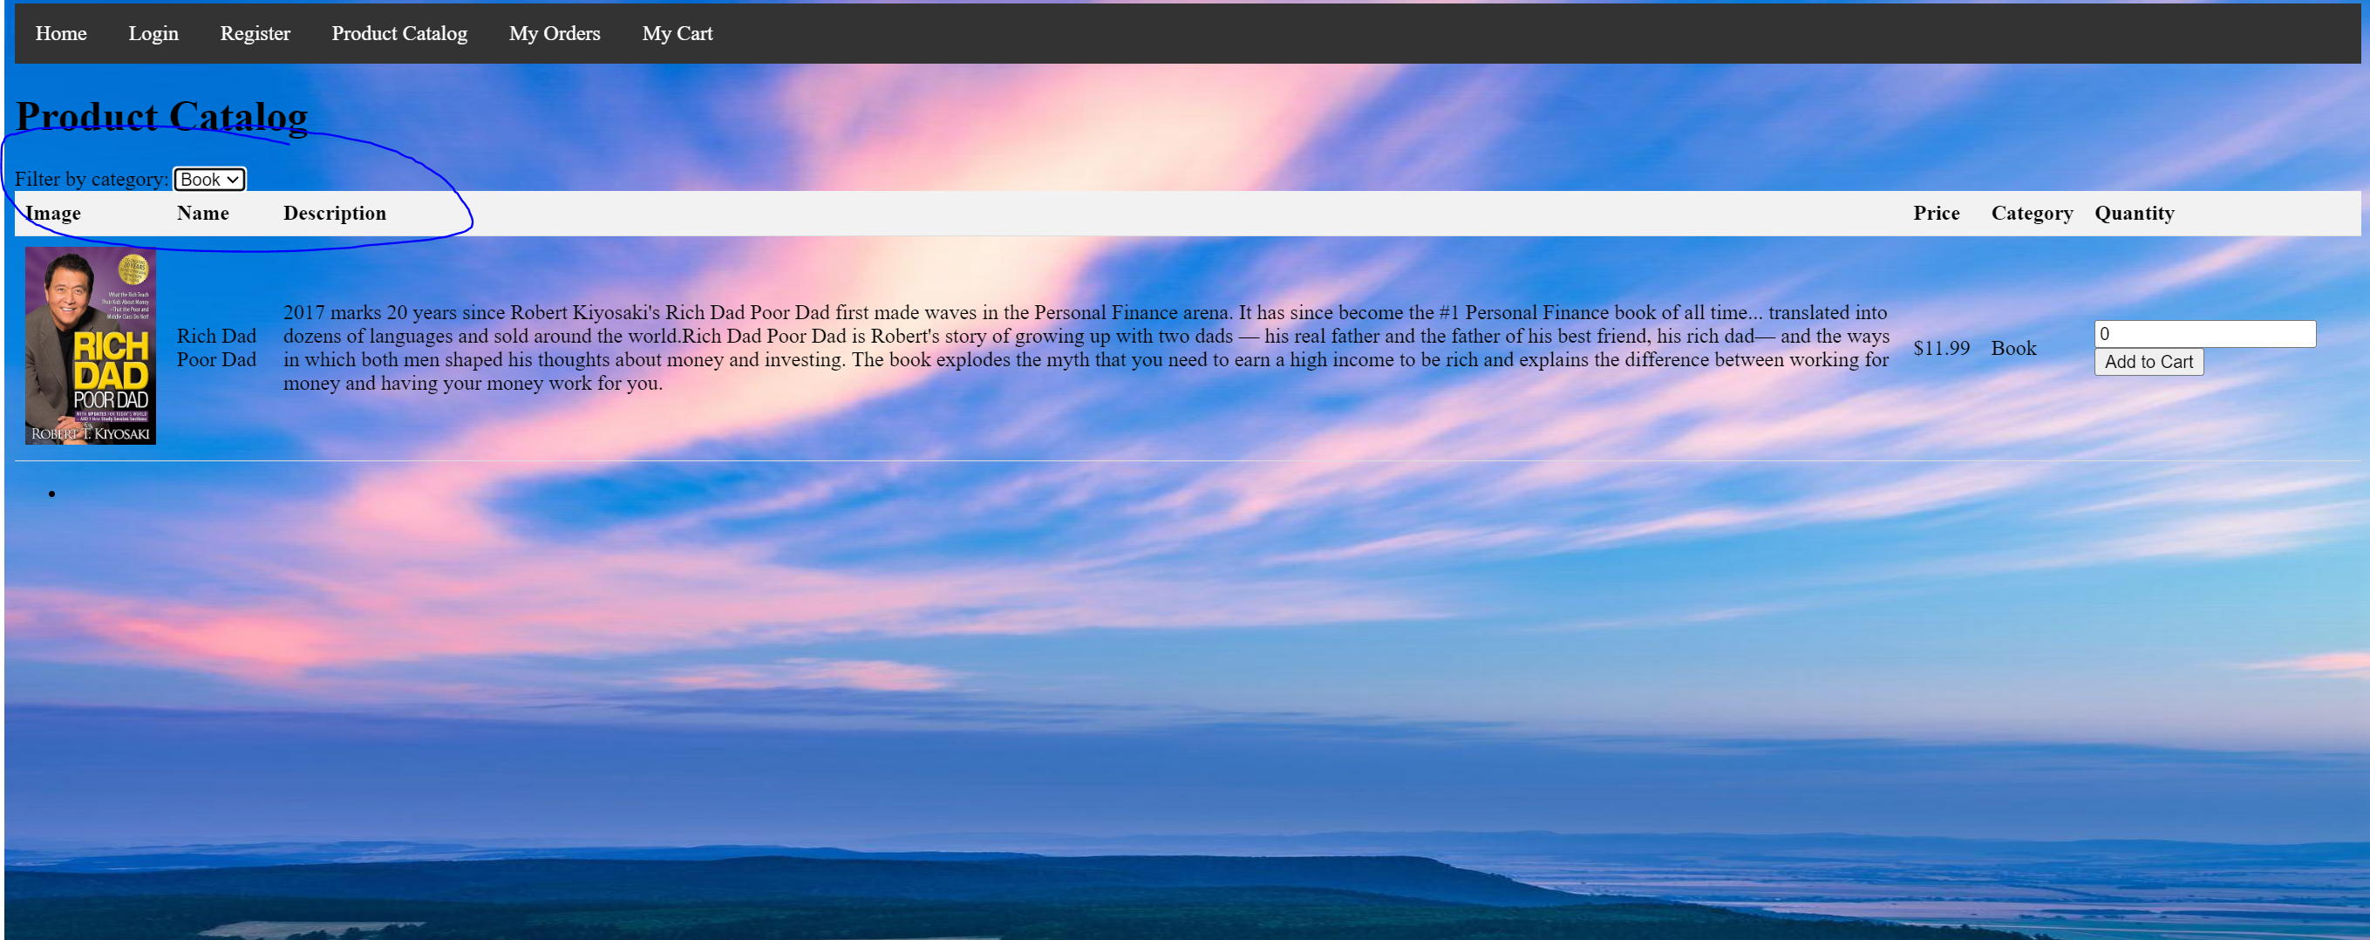

* 1. Add product into cart – Non admin users can add any amount of product in the product Catalogue into their account.

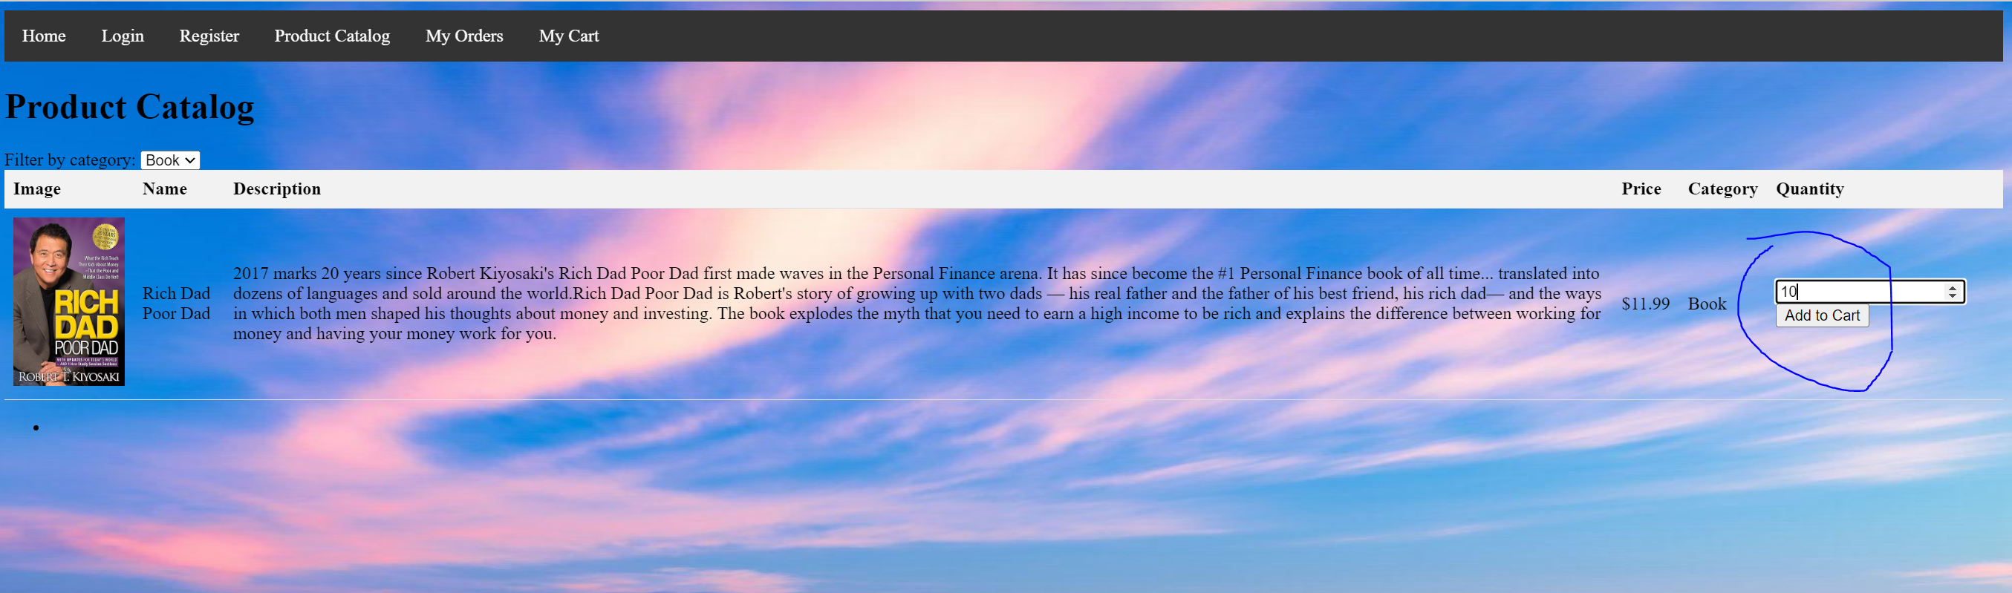

In cart page, the program shows all products user added to the cart with a total price displayed at the bottom.



* 1. Change product quantity in Cart and check – Non admin users can change the quantity in the cart by using the update cart button.

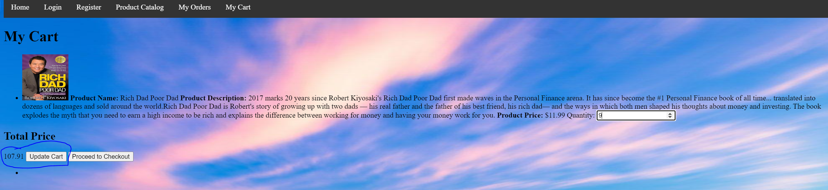

Press Proceed to check out bottom will redirect user to payment page.

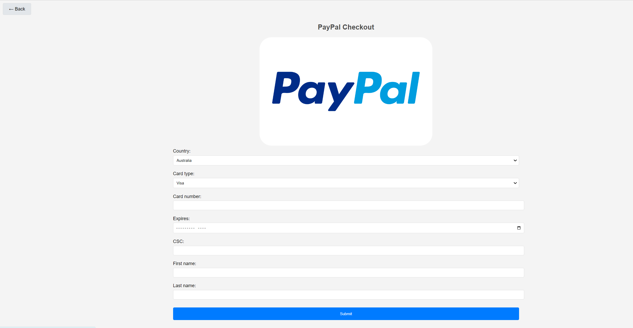

After input correct payment detail press submit to go through payment or press back on the top left corner to redirect to cart page.



* 1. View historical orders – In order page, users can view historical orders (paid) with an order id 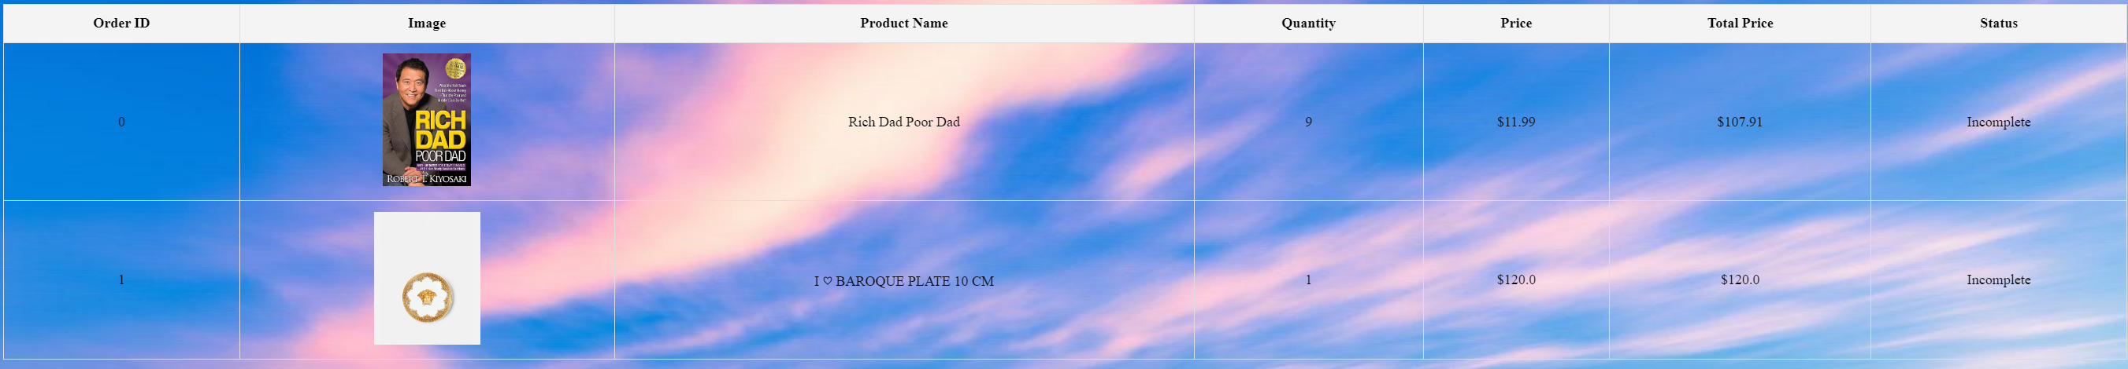
  2. Access Admin account – In login page, type username : admin , password: password to login Admin account

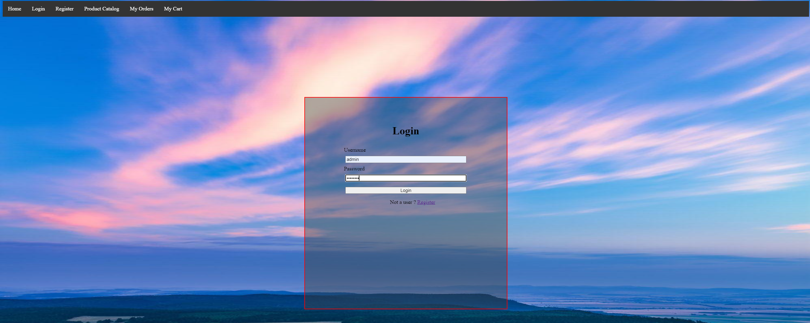

* 1. Add new product – Type product name , product description , price category, image URL and press add product

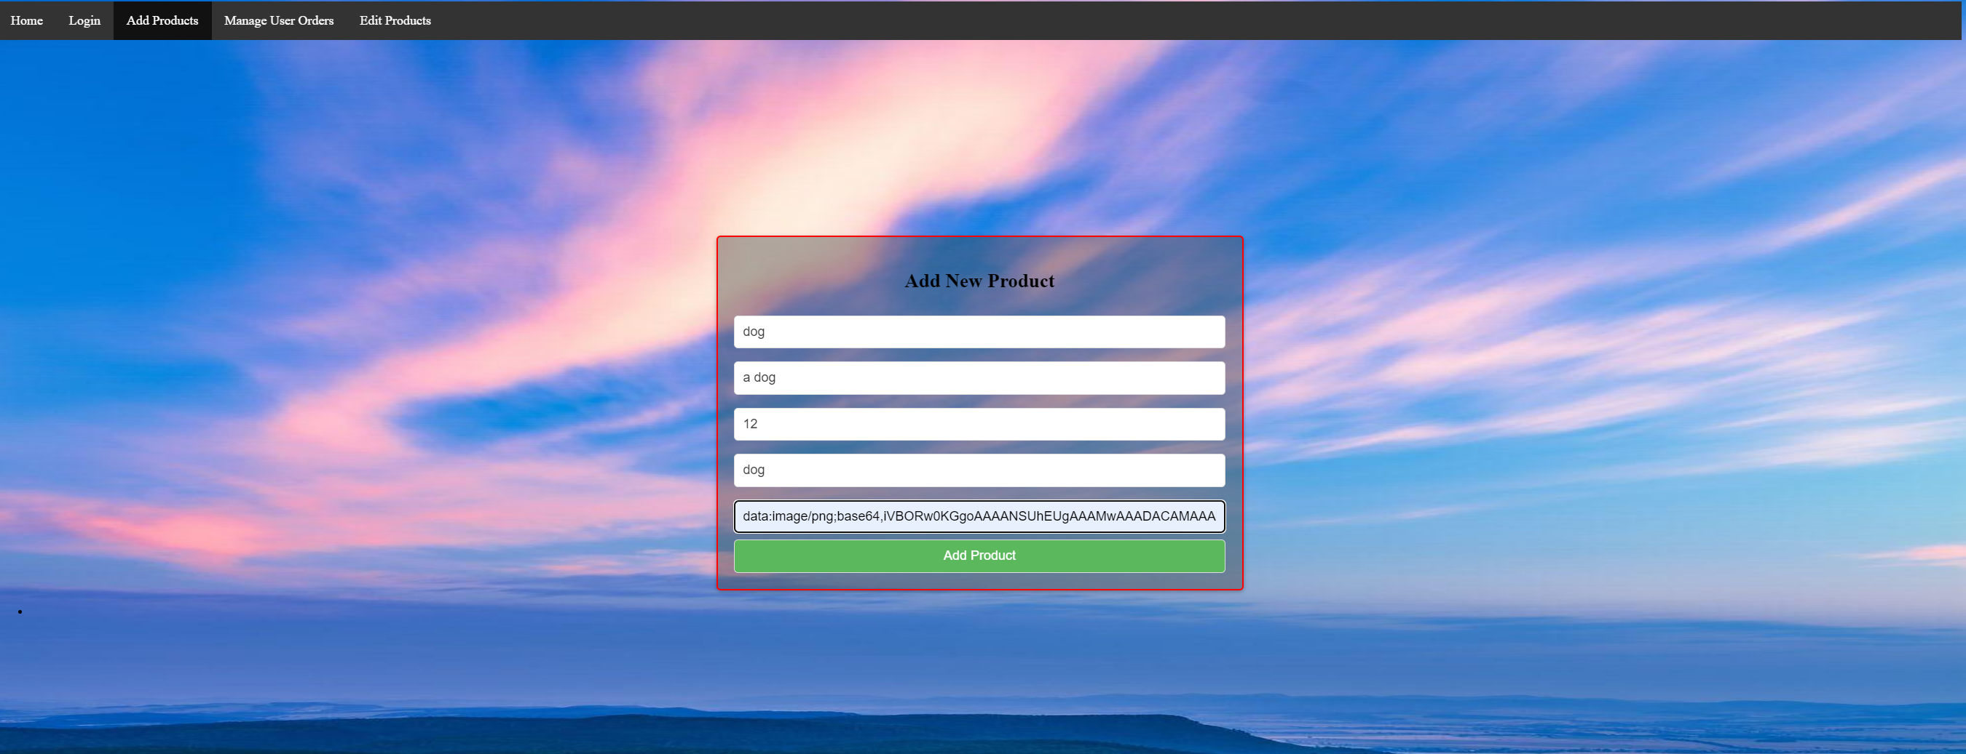

* 1. Modify product – type the new name , description, price, category, image URL and press update

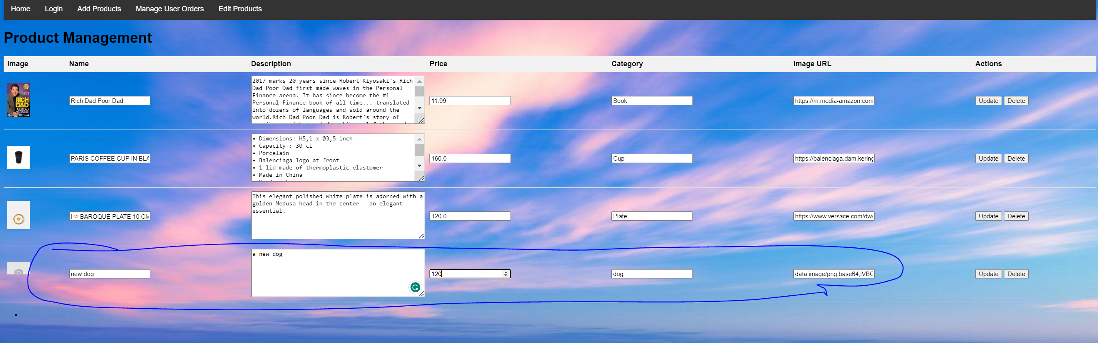

Admin can delete product. For example: delete the new dog product by press delete next to the product.

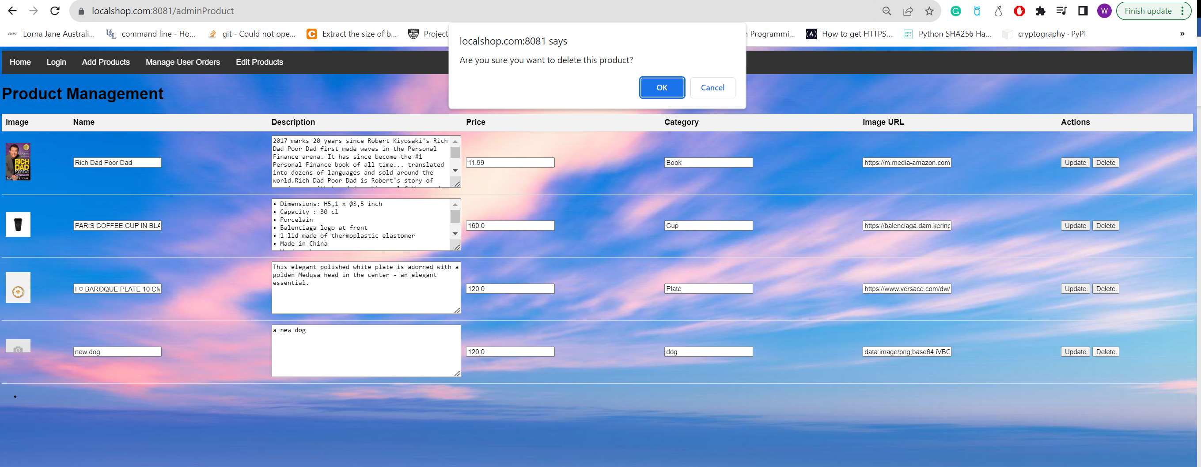

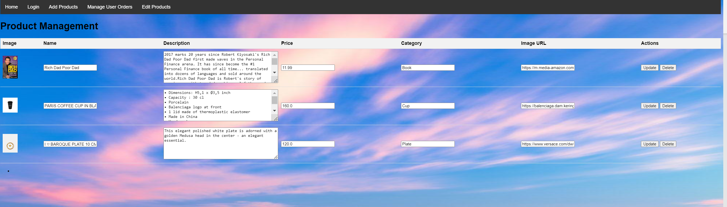

* 1. View Complete all orders from users in Admin - In status column, select new status and press update to change order status. Admin can go to specific user’s order by filtering orders by username.

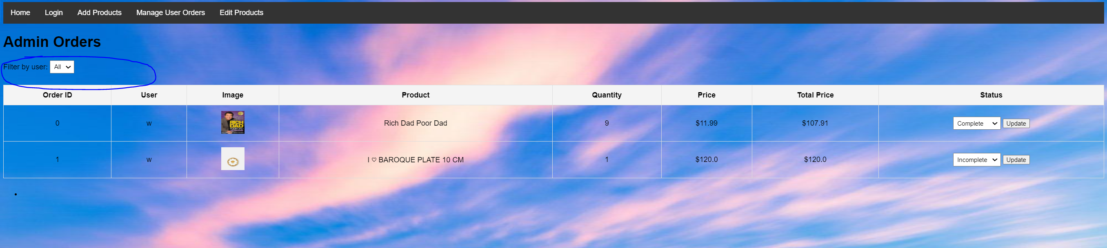

2. Design documents (Design workflow)

2.1 Set up database using PostgreSQL

2.2 Implement and conduct testing on the various SQL functions using the SQL alchemy and psycopg library in python.

2.3 Connect the python SQL function to the PostgreSQL database

2.4 Build backend Server on python using the Flask library

2.5 Build frontend HTML templates, with all the pages of functionalities as per system specification

2.6 Enable connection between the frontend and backend applications using the @Post submitting and handling methods provided by the native HTML and the flask library respectively

2.7 Conduct component and system testing of the overall system to ensure that the web application provide works seamlessly.

2.8 Add additional adjustment on the aesthetic layout on the HTML page to ensure consistent, Concise, Responsive, Efficient, Intuitiveness and user-friendly Interface has been well incorporated.

3 Implementation

Database: create a local database to store all data into Tables using PostgreSQL and connect it with our python server using **SQL alchemy and psycopg library.**

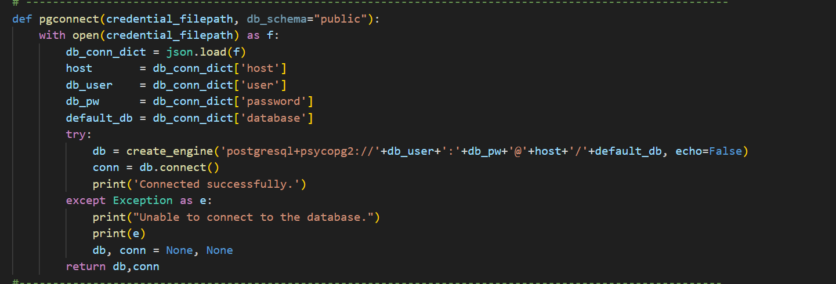

Setup shop schema and table products, users, cart, hist

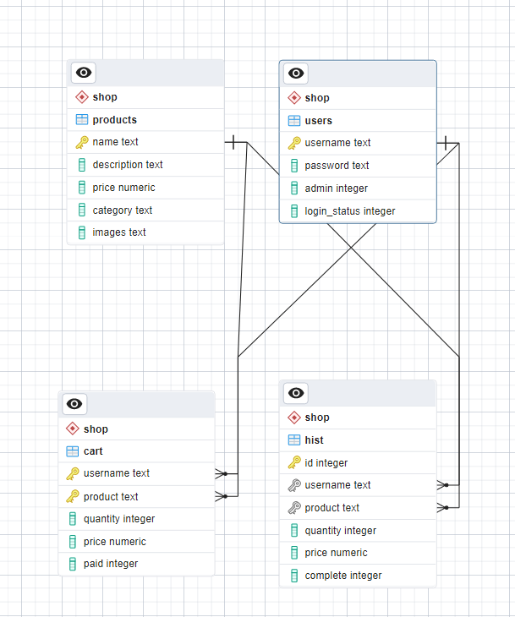

In users table, we set the username as the primary key for the table. In the products table, we set name (product name) as the primary key. In cart, we reference username from users and product from products(name) and use them as our primary key. This is because all username in the cart must be registered users and products in cart must be products in the in the product CatLog. And in his we store all the historical orders, reference username and product from users and products(name). But this time we create a new variable called id to be the primary key to allow the same customer to buy same goods multiple time.

Product CatLog:

Create a user-friendly product CatLog that displays various products, including. Details like name, description, price, and images.

Storing Product data: In the product table, user must provide products details including name, description, price, and images. For images, user will input an image URL, so the actual image is not stored by the database.

Rendering: When display the product details to user, the system run a select statement in PostgreSQL , the result returned by DBMS will be converted into a python list and rendered on the html page.

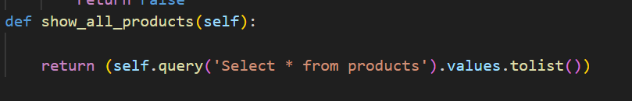

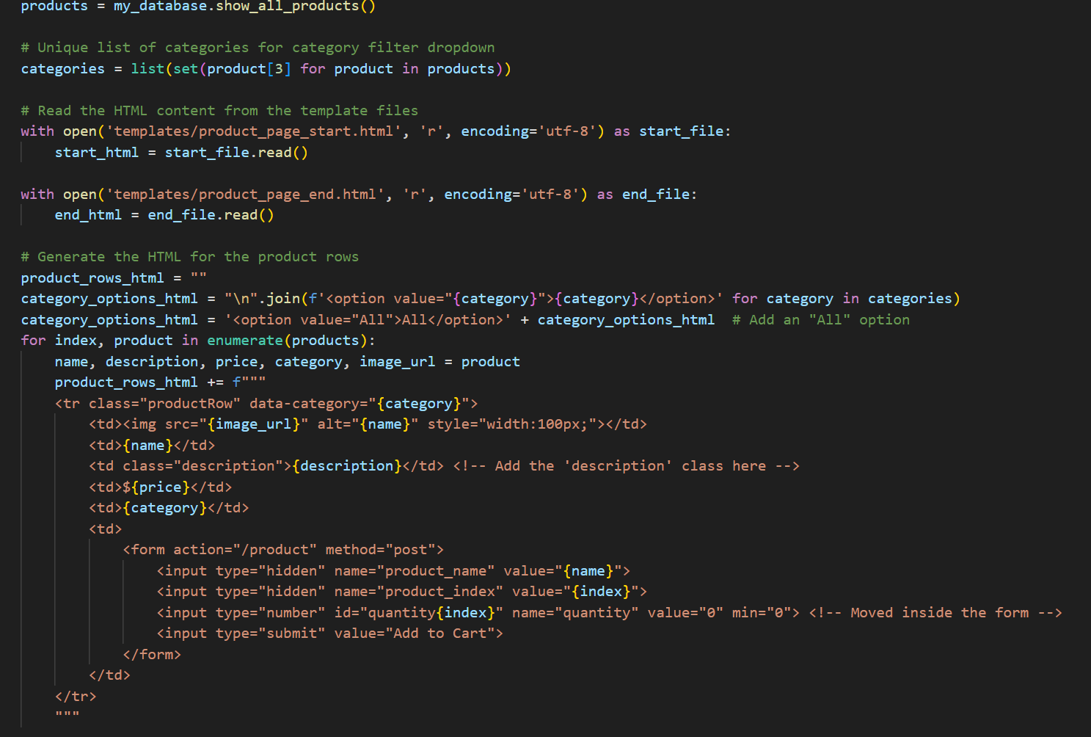

Implement categories and filters to help users browse and find products easily.

In html, we add a JavaScript to filter products, the system does not allow user to manually input the category, instead the template provide a drop-down list that contains all categories in project table. When the user selects the category, the template will only display the product within that category.

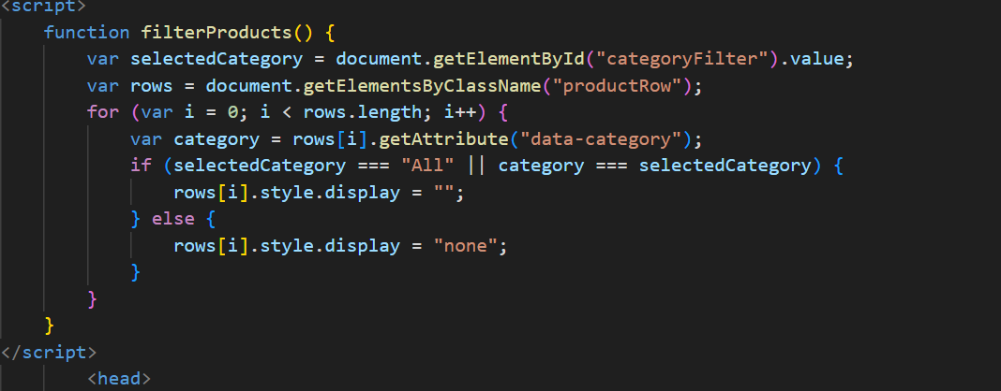

Allow administrators to add, edit, and delete products through an admin panel.

Modifying database: Use update, insert and delete statement in PostgreSQL to change the products table , after receiving requests for corresponding instructions from html template. Error messages are generated when admin leave empty fields when they adjust or add new products.

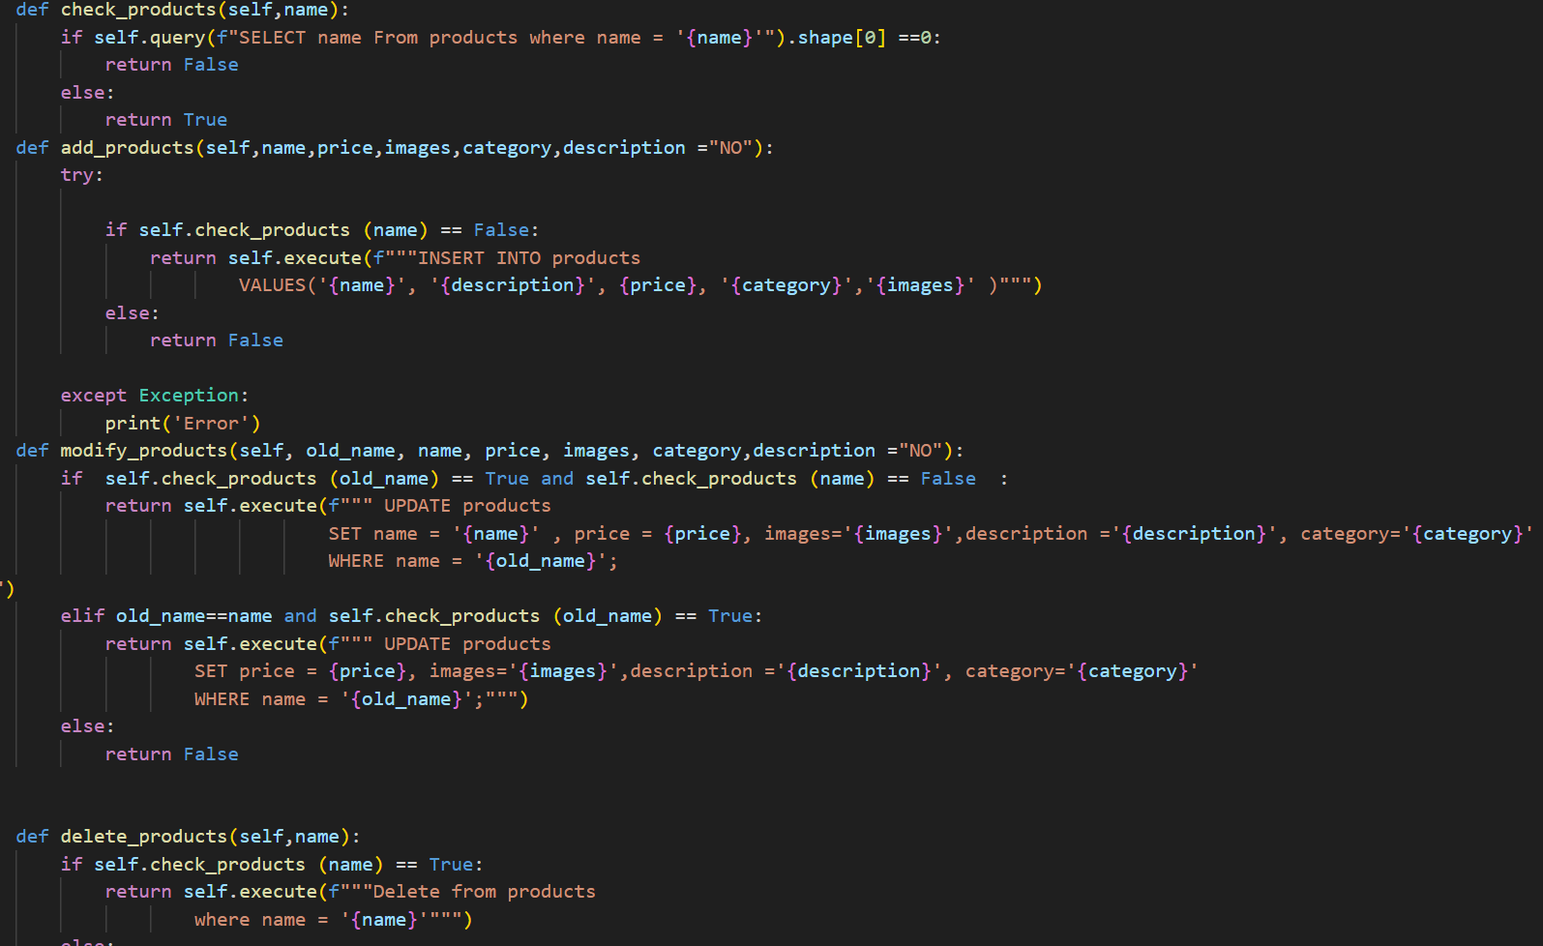

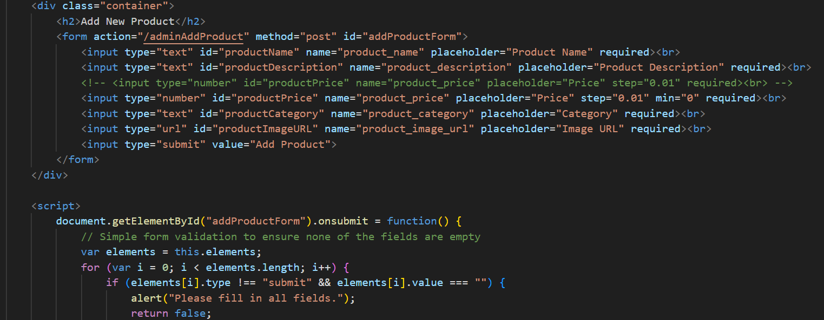

Shopping Cart

implement a shopping cart that allows users to add products, update quantities, and remove items.

Modifying database: Use update, insert and delete statement in PostgreSQL to change the cart table, after receiving requests for corresponding instructions from html template. Error messages are generated by the html template when admin leave empty fields when they insert invalid number or text into the text box.

Provide a summary of the items in the cart, including the total price.

Rendering: When display the cart details to user, the system run a select statement in PostgreSQL , the result returned by DBMS will be converted into a python list and rendered on the html page. The total price is calculated on the html template.

Allow users to proceed to checkout from the cart.

Rendering: After the python server receives the request to access checkout page in the html it will redirect the page into payment page.

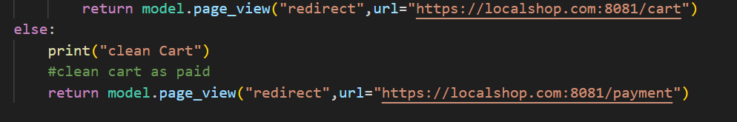

Security Gateway:

Integrate a secure payment gateway to enable users to make secure online payments.

Payment: we built a payment gateway ourselves, the python server request from the html page and automatically prove the transaction. The server do not check the card details and html template does not allow empty inputs.

Ensure payment information is encrypted and protected.

Security: Since we are using https connection when hosting the local website. The encryption, data integrity and authenticity are automatically provided in the connection. That means Data is encrypted via Transport Layer Security protocol (TLS), which ensures that data transmitted between a web server and a browser remains private and secure.

Order management system:

Develop and view an order management system for users and administrators.

Storing Order data: After user go through the payment process all the products in user carts will be insert into the hist table (historical orders) through PostgreSQL and those products in the cart will be deleted after a successful insertion.

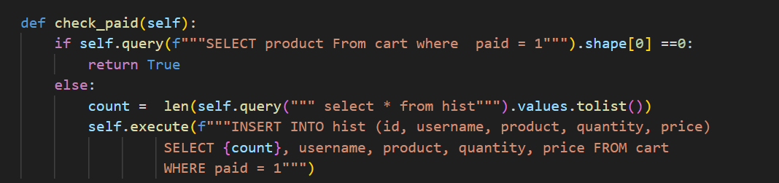

Rendering: When display the historical order details to user, the system run a select statement in PostgreSQL , the result returned by DBMS will be converted into a python list and rendered on the html page. When rendering, the python server will check user’s username and login status in the database. If the username is admin the server will select all the historical orders , if the username is not admin the server will only select orders under that username.

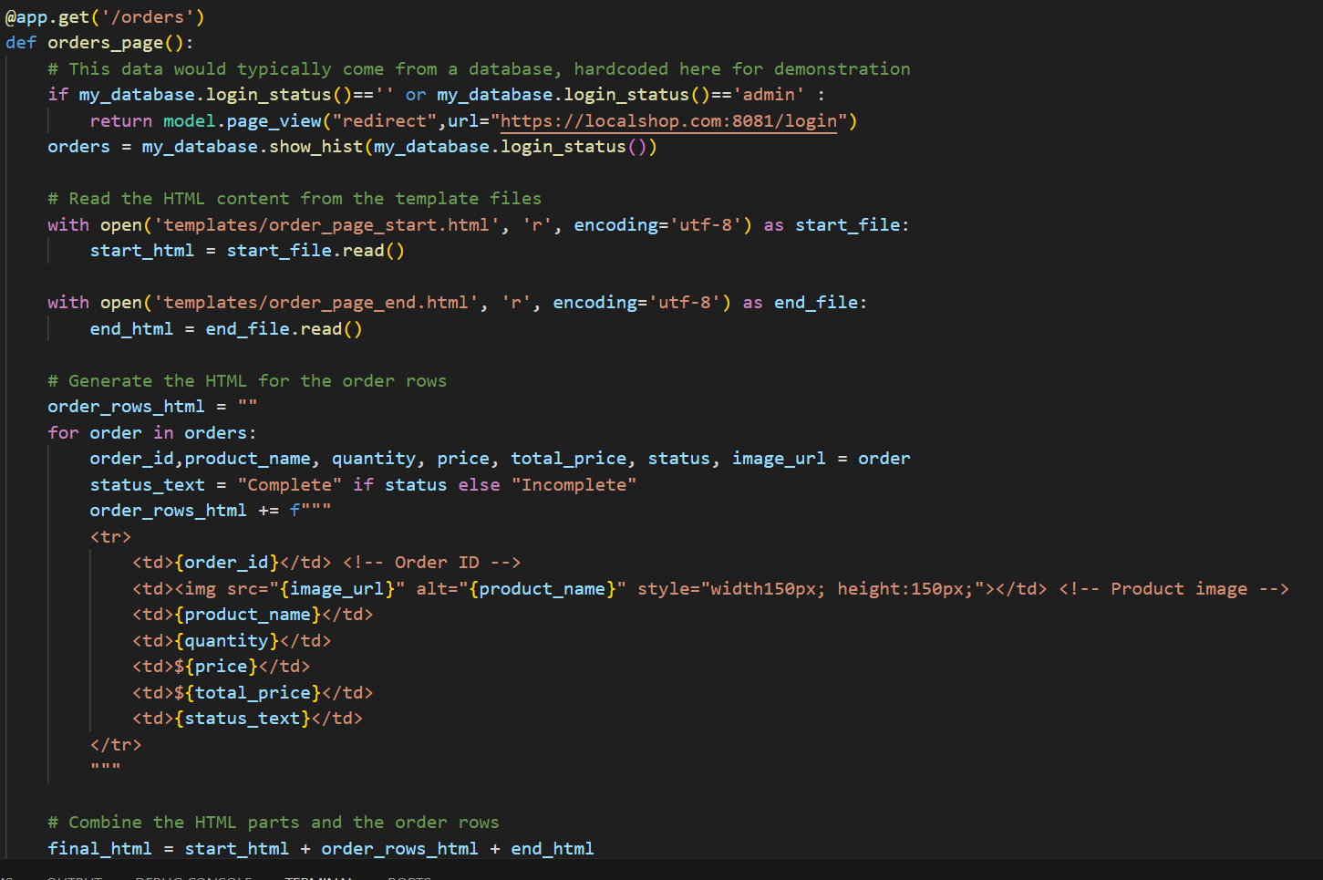

Administrators change order status.

In the admin order page, Admin user can change the order complete status. The python server will request the admin action on the page. Based on the action given, it will do an update on the database and change the complete status in the order table.

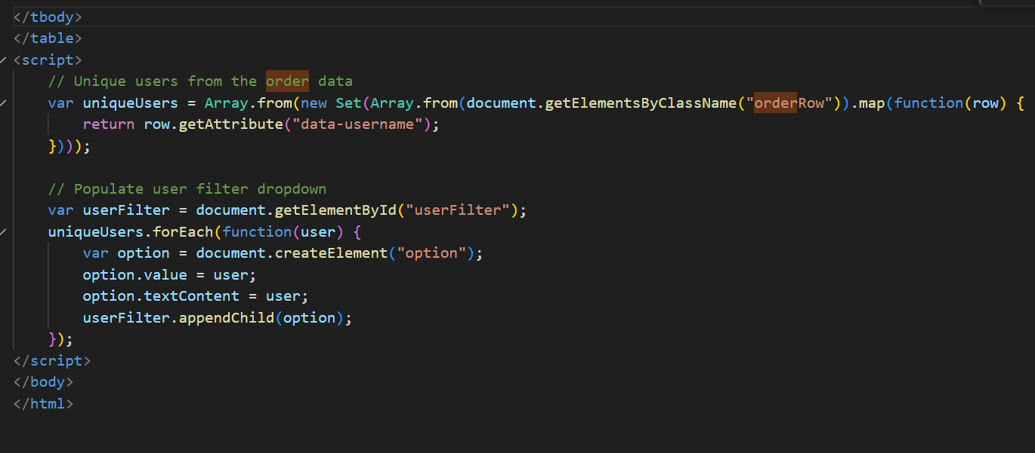

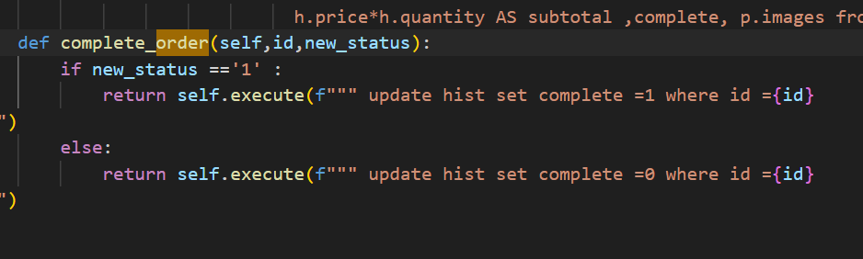

5 User authentication

We have setup 2 roles of users in the system: the basic user and the Administrator.

Baisc users are entitled to access the product catalogue page, their cart page, order page and payment page (when they are prompted).

Basic users are required to login (or otherwise to sign up) to access their cart and order history page.

admin users are entitled to access the “add Product”, “Edit Product” and “Manage Orders” page.

like basic users, admin users also need to login their admin account to access their rights as an admin (I.e. access the pages in 5.4).

Unlike users, admin accounts cannot be registered, but redefined by the system in the database

The pages between which a basic user and an admin user can access are mutually exclusive.

Limitation of our system: due to our system requirement as being a local server, it is only possible for one user to interact with the page at any point in time. If another user wants to access it, the previous user needs to be either actively or passively sign-out out from the system.

5.1 We have setup 2 roles of users in the system: the basic user and the Administrator.

5.2 Baisc users are entitled to access the product catalogue page, their cart page, order page and payment page (when they are prompted).

5.3 Basic users are required to login (or otherwise to sign up) to access their cart and order history page.

5.4 admin users are entitled to access the “add Product”, “Edit Product” and “Manage Orders” page.

5.5 like basic users, admin users also need to login their admin account to access their rights as an admin (I.e access the pages in 5.4).

5.6 Unlike users, admin accounts cannot be registered, but redefined by the system in the database

5.7 The pages between which a basic user and an admin user can access are mutually exclusive.

5.8 Limitation of our system: due to our system requirement as being a local server, it is only possible for one user to interact with the page at any point in time. If another user wants to access it, the previous user needs to be either actively or passively sign-out out from the system.

4.1 System test for login, register system

Log in with incorrect username: wwh and password: p. With correct username: admin and incorrect password: p The system will redirect to Error page, user can use the link to redirect into the login page.

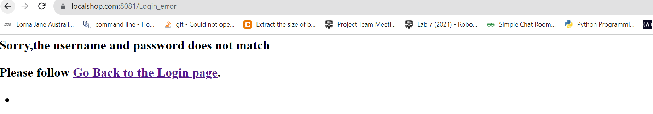

Log in with correct username: w and password: 1234, login with correct admin password. The system returns product page and add product page respectively.

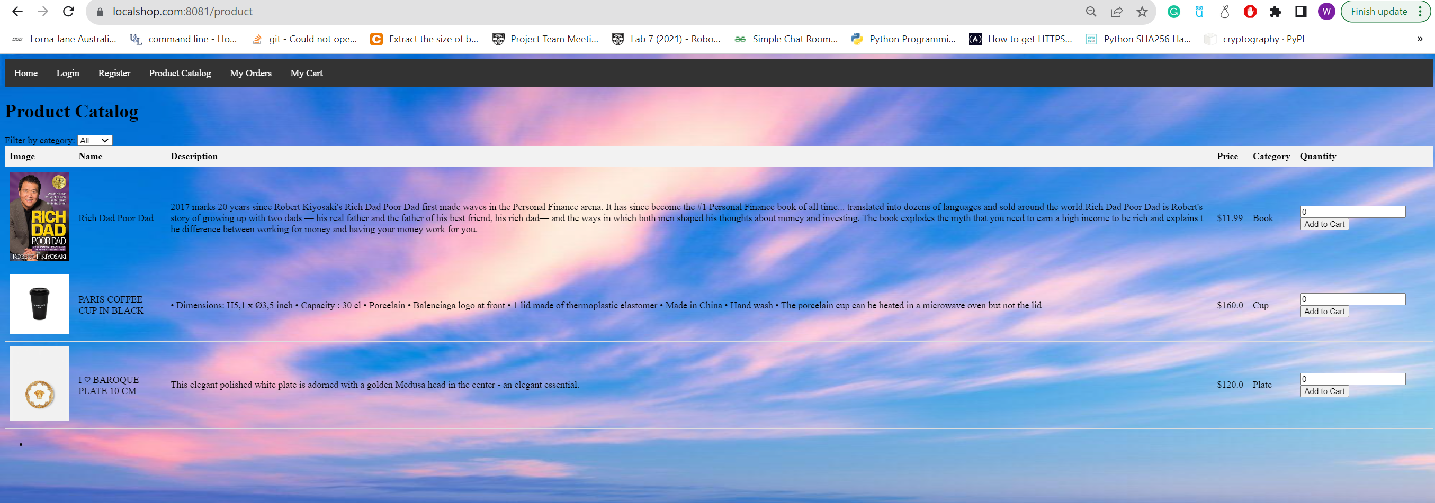

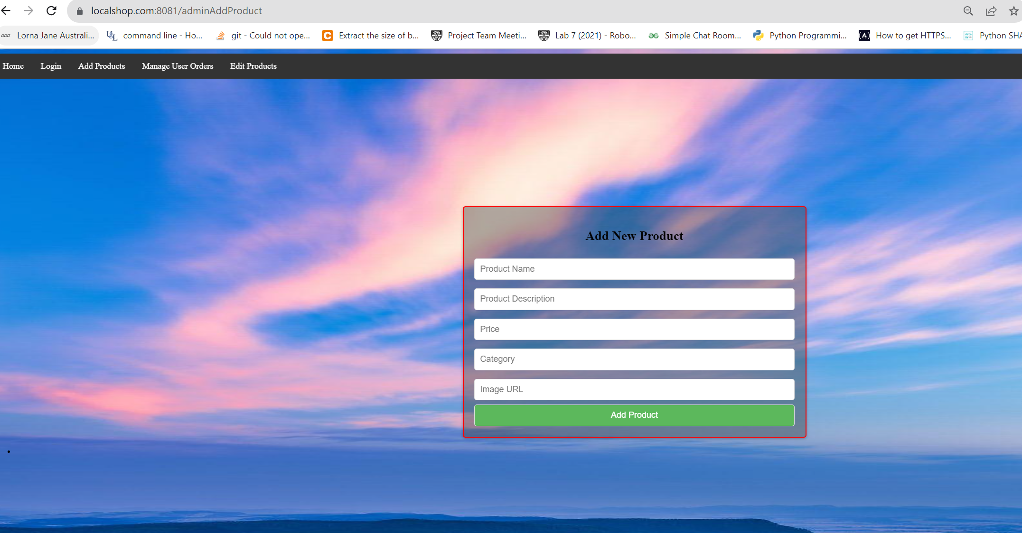

Register with existing username: w. The system will redirect to Error page, user can use the link to redirect into the register page.

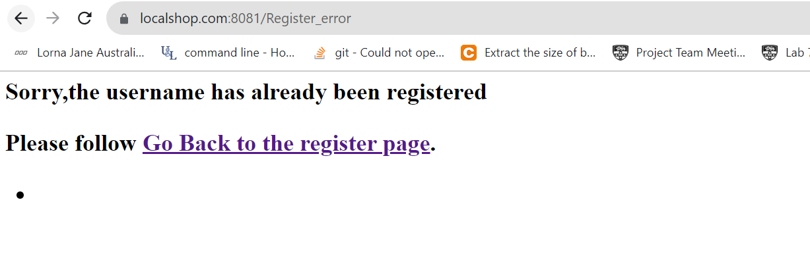

Register with a non-existed username: wwh ,password:123 the system will redirect to log in page and user can log in with that username and password.

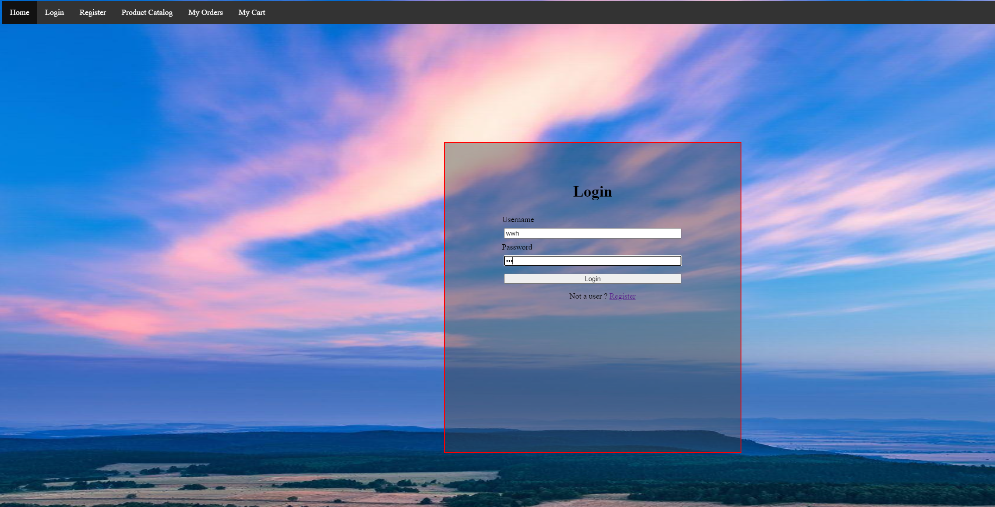

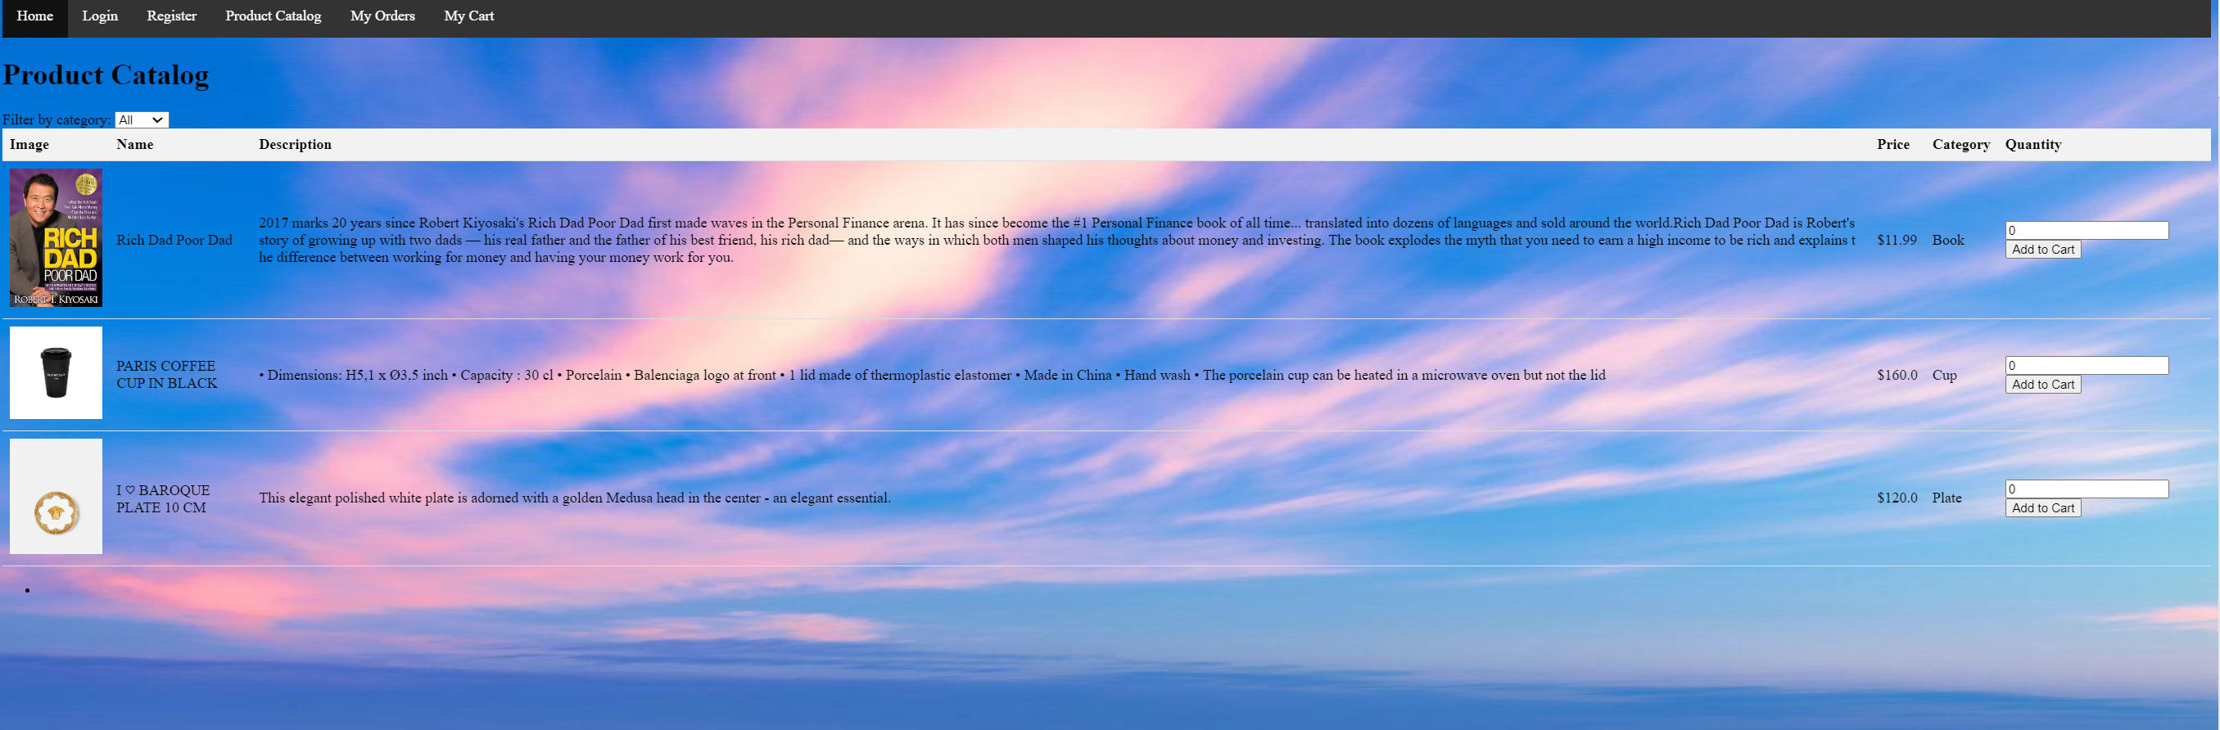

4.2 System test for – Cart and payment

Add negative value into the quantity column. System informs user to add a positive value.

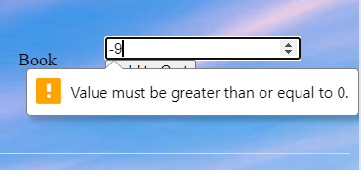

Add fractions into the quantity column. System informs user to add an integer value.

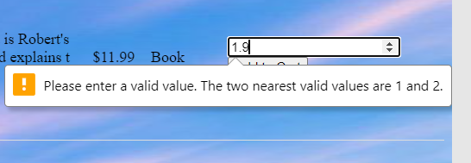

Add non numeric value into the quantity column. User can not add any non-numeric value into the textbox

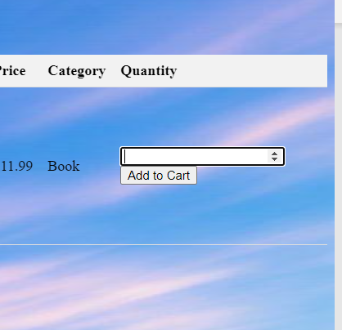

Add a positive integer 12 into the quantity column, User can see the there are 12 books added to their cart with a subtotal.

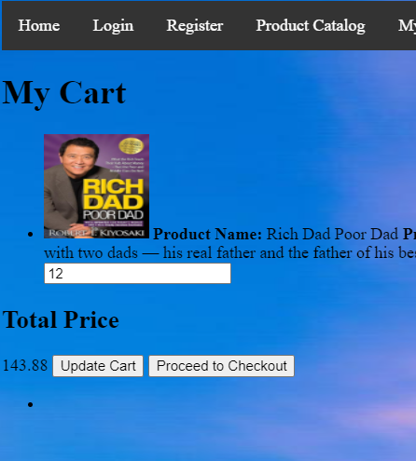

Add again, User can see 24 books in their cart and totals are updated.

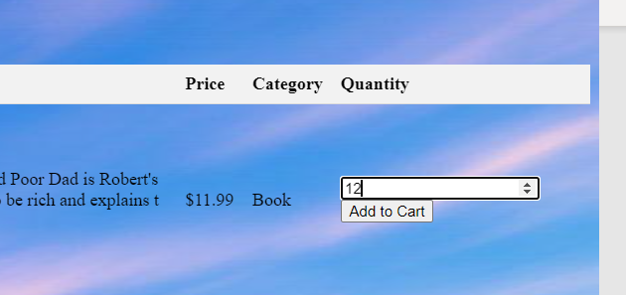

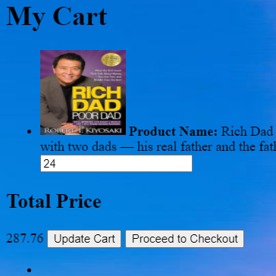

Update the quantity to 1 in cart, the total price changed to 11.99.

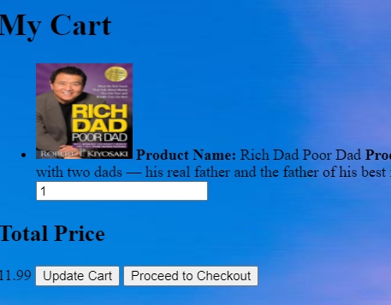

Update a decimal quantity. Server notify user to add a integer value

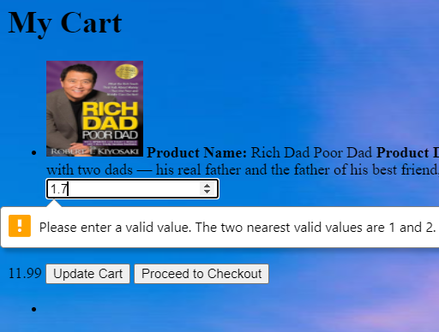

Update with negative quantity, Server notify user to add a positive integer.

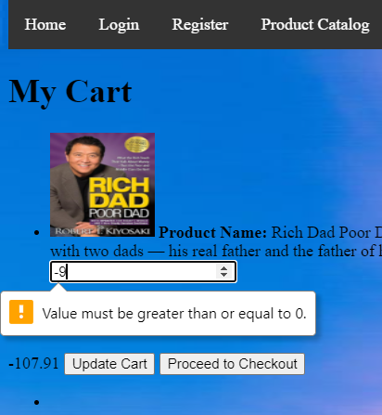

Proceed to check out page will redirect user into the payment page.

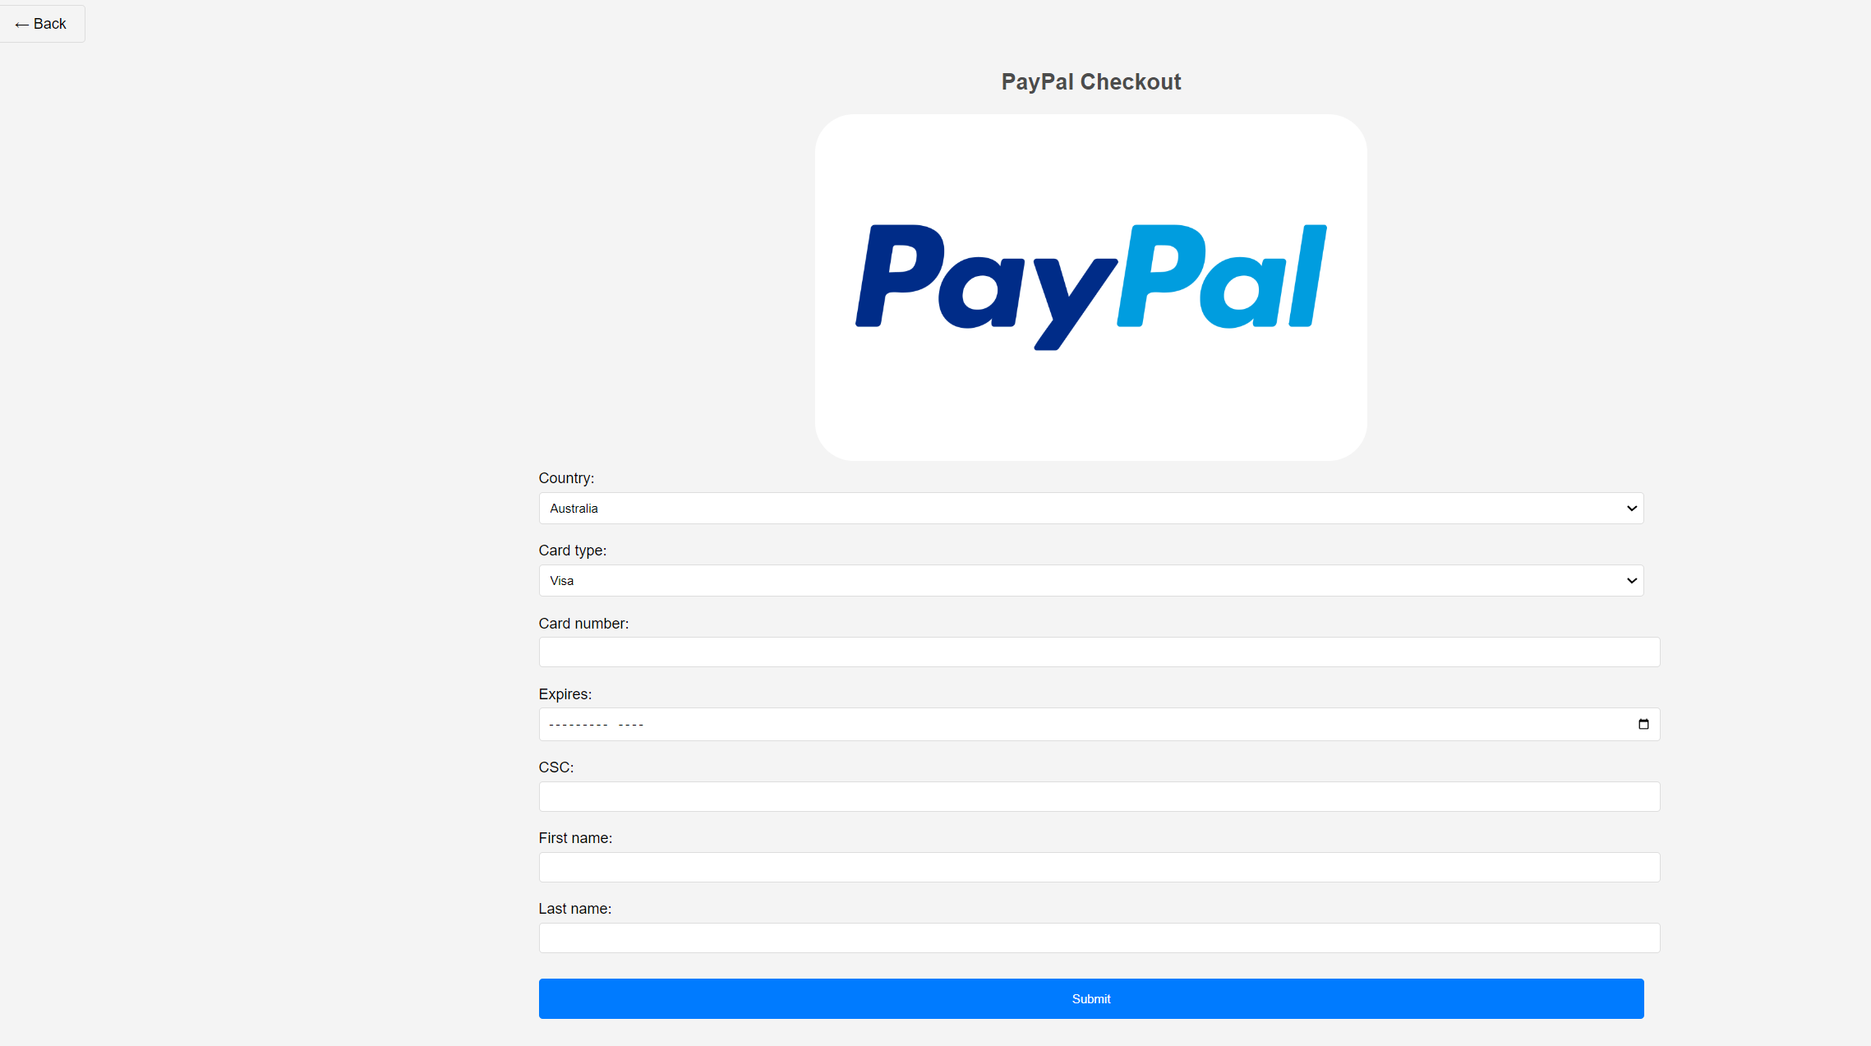Fill in all the details, the payment will be successful and return a bottom to redirect user to their cart page. (It is empty)

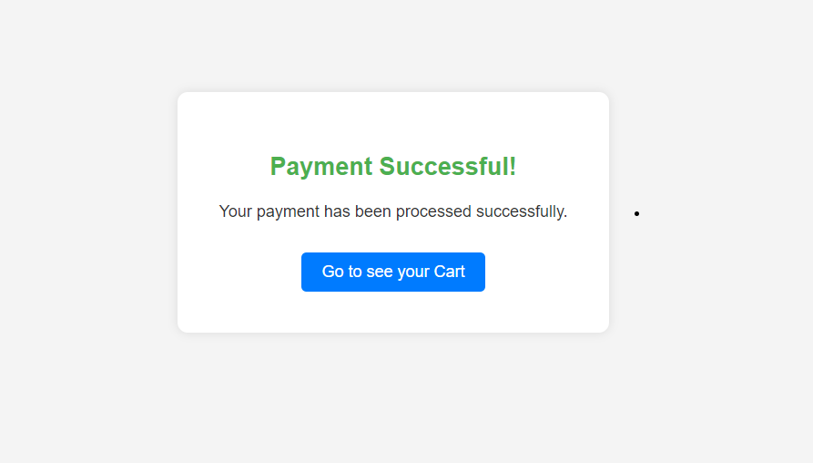



Check historical order - the order page will show us the book we just bought

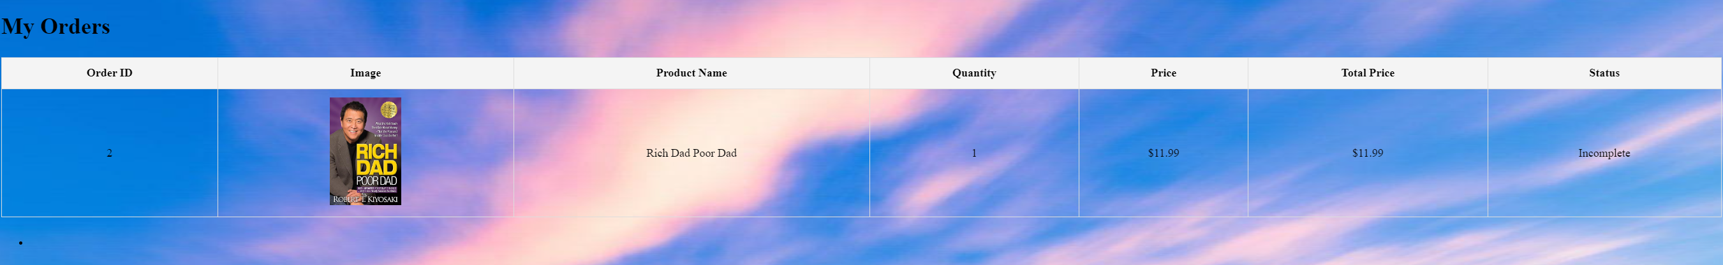

4.3 System test for Admin functions

Add new product in Admin page – In product page, the new added product dog should be displayed.

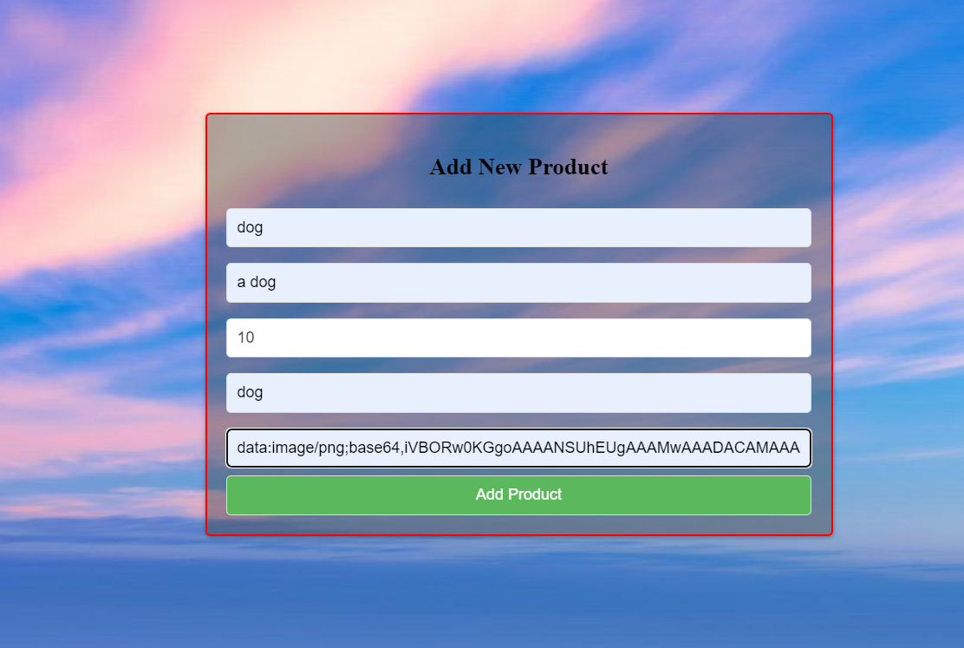

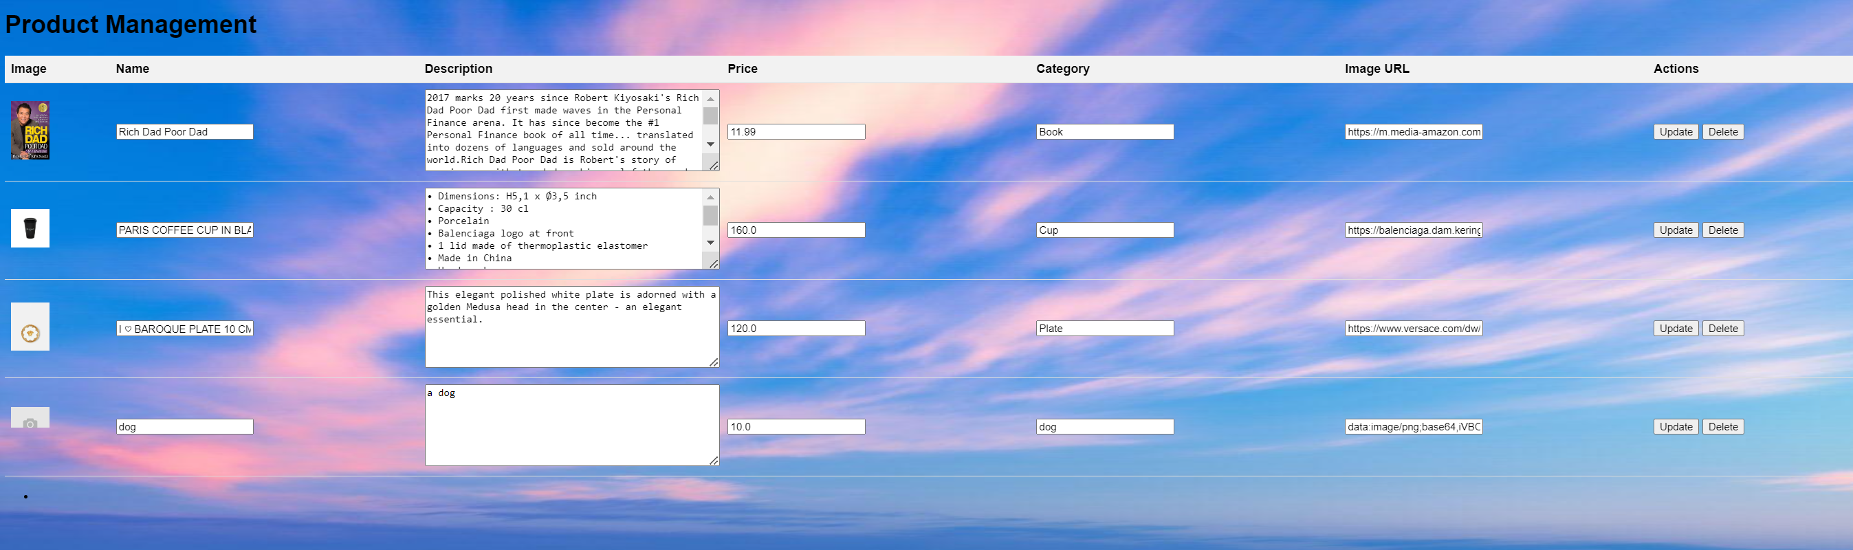

Modify the content of the product- change the product name of dog to new dog and price to be 22. The modification should be successful.

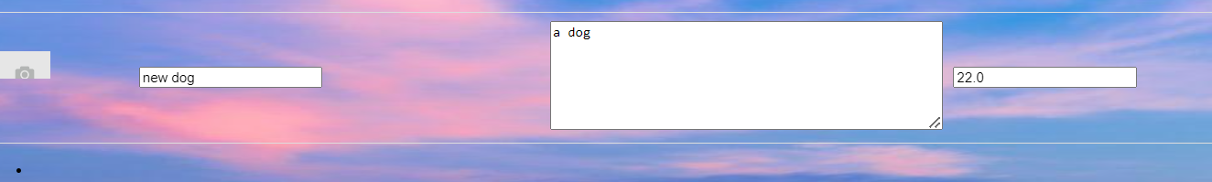

Modify the cups name to new dog – such change will no be conducted as the name for product must be unique.

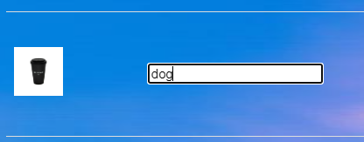

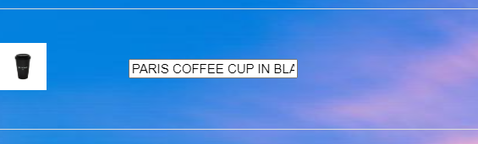

Manage user orders –Change the order with id 1 to be complete the system correctly change order 1status to be completed

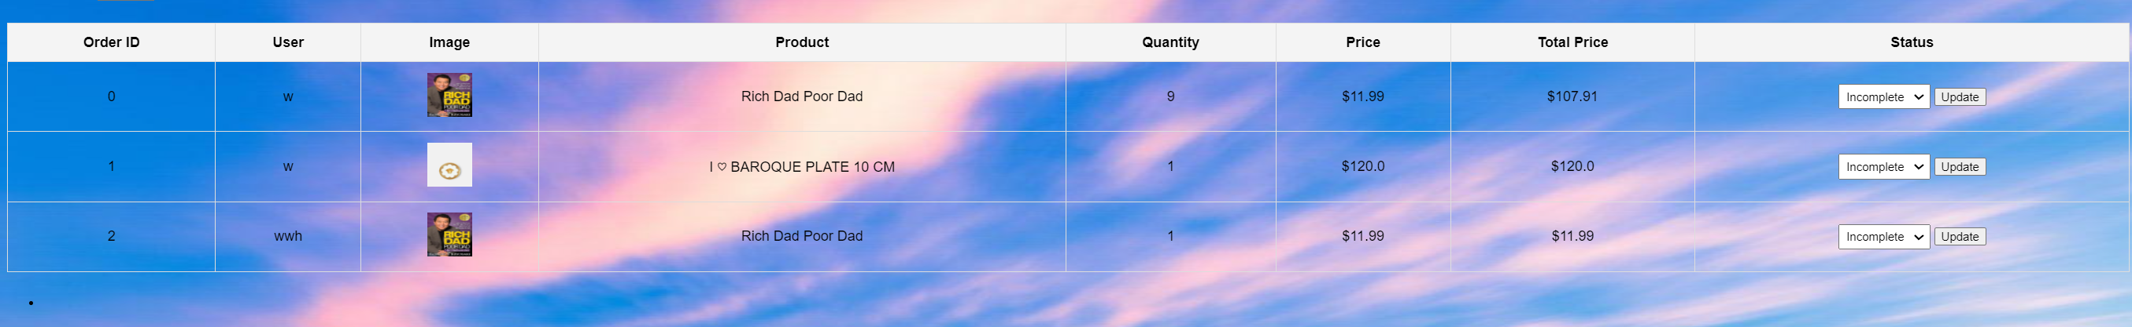

4.4 Unit test for database

Test_add_cart tests functions including functions like add_cart, add_user, show_user_cart ,set_cart,clean_chart,show_user_cart, in sql.py. The test first create a new user and add 10 products named Rich Dad Poor Dad into the cart twice , then displayed to cart, check if 20 products are added, then set the number of products to be 0 and remove products with a quantity of 0.

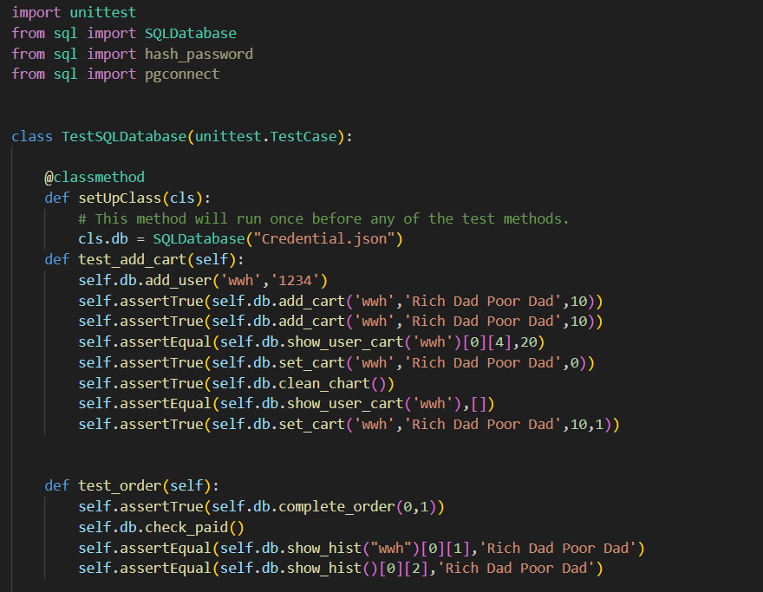

Test_order test functions like complete_order,check_paid, show_hist. The test change the the complete status of order id 0 to complete then check if show_hist can correctly return the list of orders.

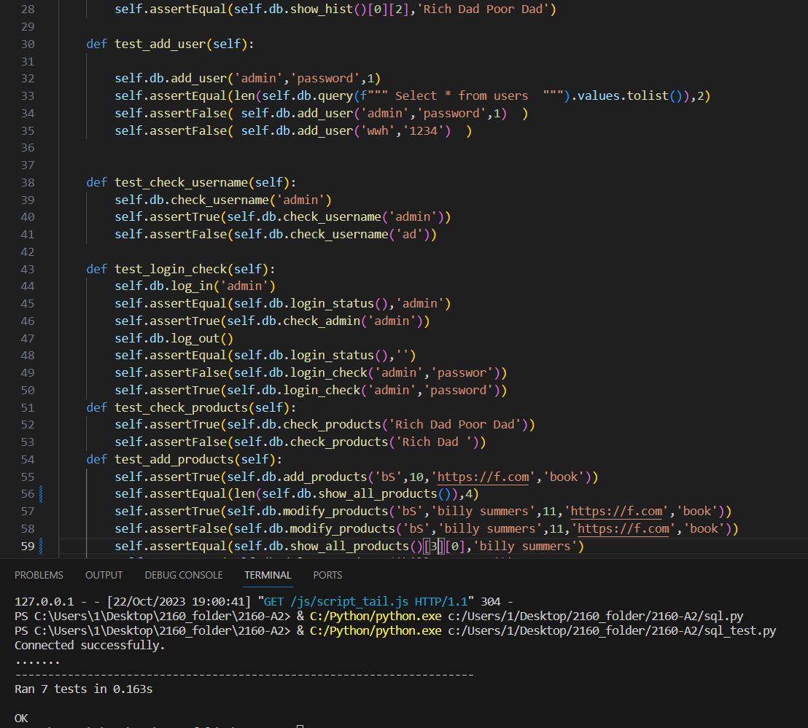

These tests are used to test whether they database can correctly add, modify and delete products and check user credentials with database. These functions eventually add up to create our local shop website.